Oh, the Economics You Can Play
Human behavior. There is simply no way to avoid thinking about human behavior when talking about either politics or economics. The political side makes assumptions and then argues about what is right and proper and ought to happen. The economic side observes and then poses questions about the best way to answer how much, who makes, and who consumes. The political sphere tends to value emotion over data, and the cost of each decision is ‘obvious’ and ‘visceral’ and ‘in your face’. In economics, the situation is reversed, with hard facts trumping knee-jerk reactions, and where the costs of each decision are often ‘hidden’ and ‘counter-intuitive’. And yet both disciplines deal with the same underlying enigma – human beings. As a result, it is almost always the case that there is spillover between the two sides, in which the salt water from the political ocean mixes with the fresh water from economic rivers that fed it to form a sort of brackish overlap.
This past month saw a particularly interesting ‘brackish’ situation emerge surrounding one of the most colorful characters in literature, Theodore Seuss Geisel aka Dr. Seuss.
According to Wikipedia, Ted Geisel authored over 60 children’s books. According to the stack of books that once adorned the shelves in my own children’s room, we owned nearly all of them. There’s no denying that Dr. Seuss was a common fixture for many when learning to read. There’s also no denying that as many of us transitioned to adulthood, our childhood love of the perennial favorites The Cat in the Hat, The Lorax, Fox in Socks, and Horton Hears a Who! came along for the ride (not to mention our yearly need to see the Grinch in the weeks leading up to Christmas). Seuss’ work resulted in numerous movies, TV shows, and related media (including a hilarious reading of Green Eggs and Ham by Jesse Jackson on Saturday Night Live). Dr. Seuss wove himself and his eccentrically drawn characters into the fabric of American life (but just how deeply will be discussed below).

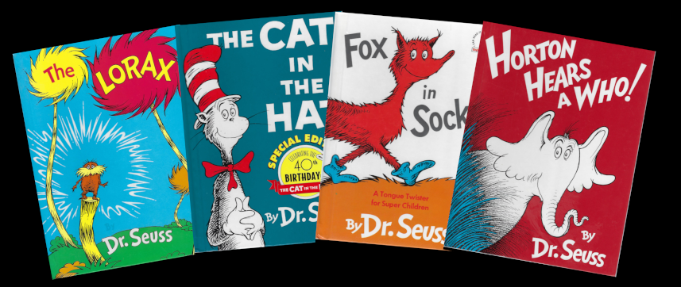
It is against this backdrop that a controversy erupted early in March when the publisher, Dr. Seuss Enterprises, announced that they would no longer be printing the following 6 titles:
- And to Think That I Saw It on Mulberry Street,
- If I Ran the Zoo,
- McElligot's Pool,
- On Beyond Zebra!,
- Scrambled Eggs Super!, and
- The Cat's Quizzer.
This sparked a political firestorm on both sides of the spectrum, but the controversy lasted far shorter than the publishers most likely had hoped. But before arguing the underlying facts that support this, admittedly, provocative conclusion, let’s look at what the politics had to say in order to better understand how their emotional response provided cover for what was most assuredly a savvy economic move on the part of Dr. Seuss Enterprises.
According to Yahoo! News in a piece they published on March 2nd entitled Six Dr. Seuss Books to Stop Being Published Due to Racist Imagery: 'Hurtful and Wrong', Dr. Seuss Enterprises has decided to stop publishing the list of 6 books by the late author because of “racist and insensitive imagery.” The article went on to quote the publisher saying that the titles in question:
<[P]ortray people in ways that are hurtful and wrong. Ceasing sales of these books is only part of our commitment and our broader plan to ensure Dr. Seuss Enterprises' catalog represents and supports all communities and families.>
Newsweek, in their short piece entitled Banned Seuss Site Emerges to Promote Dr. Seuss' Six Canceled Books, cites a 2019 study published in Research on Diversity in Youth Literature, which concluded that
<Geisel, however, has a history of publishing racist and anti-Semitic work. [Of the] 50 books [we examined, we] found that 43 out of the 45 characters of color featured in those books have "characteristics aligning with the definition of Orientalism," or the stereotypical and offensive portrayals of Asia … [and] the two "African" characters both have anti-Black characteristics.>
According to Newsweek, the study describes anti-Blackness as discrimination, opposition or hostility against Blackness and Black people.
On the other side of the political spectrum, local radio commentators complained about cancel culture, and wondered how the cancel culture could accuse the man who put environmentalism front and center in The Lorax, and tolerance despite outward differences as the central theme in The Sneetches, of being racist.
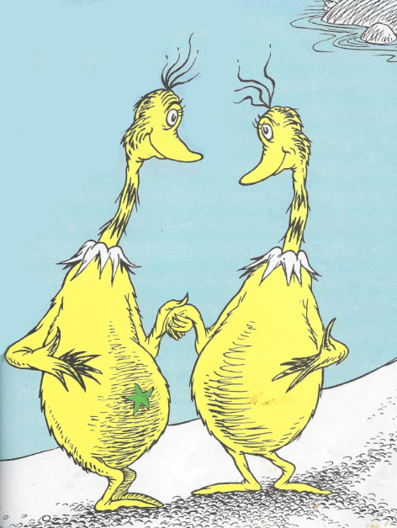
Of all the media outlets, the NY times, in its piece entitled Dr. Seuss Books Are Pulled, and a ‘Cancel Culture’ Controversy Erupts, comes closest to identifying what was really going on. After stating that:
<The estate’s decision — which prompted breathless headlines on cable news and complaints about “cancel culture” from prominent conservatives — represents a dramatic step to update and curate Seuss’s body of work, acknowledging and rejecting some of his views while seeking to protect his brand and appeal.>
the Times finally points out to its readership that
<[Seuss’ c]lassic children’s books are perennial best sellers and an important revenue stream for publishers. Last year, more than 338,000 copies of “Green Eggs and Ham” were sold across the United States, according to NPD BookScan, which tracks the sale of physical books at most retailers. “One Fish Two Fish Red Fish Blue Fish” sold more than 311,000 copies, and “Oh, the Places You’ll Go!” — always popular as a high school graduation gift — sold more than 513,000 copies.
“And to Think That I Saw It on Mulberry Street,” one of the six books pulled by the estate, sold about 5,000 copies last year, according to BookScan. “McElligot’s Pool” and “The Cat’s Quizzer” haven’t sold in years through the retailers BookScan tracks. Putting the merits of the books aside, removing “Green Eggs and Ham” would be a completely different business proposition from doing away with new printings of “McElligot’s Pool.”>
And there you have it: the decision by Dr. Seuss Enterprises (DSE) was nothing more than a clever marketing ploy. DSE could have simply stopped printing underselling books, but they knew that a perceived ban would trigger responses from both sides generating loads of free publicity. They timed their announcement to coincide with National Reading Day, which is March 2nd, a date previously chosen to coincide with Ted Geisel’s own birthday.
And their ploy worked like a charm. The price of the ‘forbidden fruit’ rose so fast on Ebay that, as CBR notes in its article entitled 'Banned' Dr. Seuss Books Delisted on eBay After Selling for Thousands,
<After news about six Dr. Seuss books being pulled from the marketplace led to skyrocketing sales online, eBay responded by delisting the six books.
The prices on eBay were becoming exorbitant, with collections of all six books going for upwards of $5,000. That changed late Wednesday into Thursday as eBay delisted the six books from the auction/online sales website.
One seller who had sold a copy of one of the discontinued books received an e-mail from eBay pointing out that the site would not allow the book to be sold because of its "offensive materials policy," explaining that “Dr. Seuss Enterprises has stopped publication of this book due to its negative portrayal of some ethnicities. As a courtesy, we have ended your item and refunded your selling fees, and as long as you do not relist the item, there will be no negative impact to your account.”>
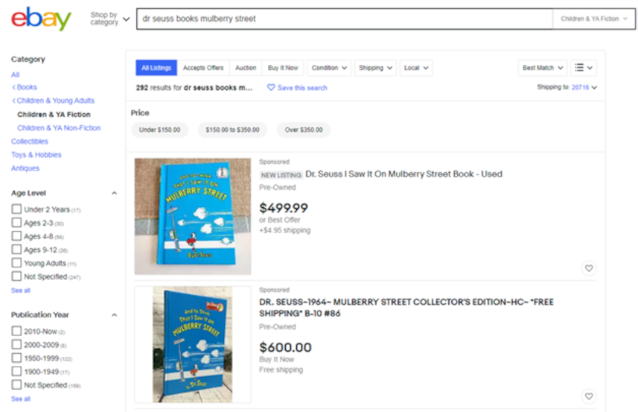
The only thing lacking in DSE’s plan was the ability to control the duration that a fickle and easily-distracted public either would stay outraged by ‘cancel culture’ run amok or would remain bitter towards perceived injustice. The controversy ended far too quickly to likely sustain an increased jump in sales but that doesn’t really matter. What does matter is that the roots of the controversy were planted firmly in the bedrock of economic analysis and not in the political winds that blow this way and that.

